**Matthew Sokolovsky**

**Homework on PROLOG**

1. Let us consider the following set of facts that describe the mother predicate.

mother(linda,paul).

mother(cathy,andrew).

mother(cathy,laura)

* Define a predicate female(X) which holds iff X is a female
* Define a predicate sister(X,Y) which holds iff X and Y are sisters
* Implement female and sister in PROLOG
* Provide screenshots

mother(cathy,someone).

female(someone).

female(laura).

female(X) :- mother(X,Y).

sister(X,Y) :- female(X), female(Y) mother(Z,X), mother(Z,Y).

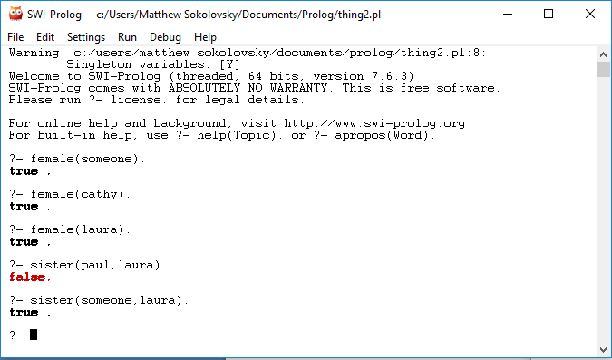

1. Implement the function g such that g(x) = x+5.

g(X,Result) :- Result is X+5.

